|  |
| --- |
|  |
| Capstone Project Document |

DANDELION

Report #1 – User Requirement Specification

|  |  |  |
| --- | --- | --- |
| **Dandelion** | | |
| **Group Members** | Vũ Công Chính | SE02585 |
| Lưu Ngọc Mạnh | SE02619 |
| Nguyễn Minh Huy | SE02723 |
| Dương Đức Anh | SE02700 |
| Vũ Ngọc Trung | SE02967 |
| Cao Thị Phương Mai | SE02908 |
| **Supervisor** | Mr. Nguyễn Văn Sang | |
| **Project code** | DDL | |

**- Hanoi, 09/2015 –**

Table of Contents

**1. USER REQUIREMENTS SPECIFICATION** 3

1.1 Introduction 3

1.1.1 Purpose 3

1.1.2 Definition and Acronyms 3

1.2 Overall Description 3

1.2.1 Business Process Overview 3

1.2.2 Product Features 15

1.2.3 User characteristic 16

1.3 Functional Requirements 17

1.3.1 Common Module 17

1.3.2 Suggest Module 17

1.3.3 Social Module 17

1.3.4 Room Module 17

1.3.5 Account Module 17

1.3.6 Management Member’s account 17

1.3.7 Management Report 17

1.4 Non-functional Requirement 17

# USER REQUIREMENTS SPECIFICATION

## Introduction

### Purpose

This document will provide the describing of general requirement and non-functional requirements of our DDL system. It also describes the requirement scope of each phase in the project.

### Definition and Acronyms

|  |  |
| --- | --- |
| Terms | Description |
| DDL | Dandelion |
|  |  |

## Overall Description

### Business Process Overview

DDL is a website. Therefore, that system will implement the following processes:

#### Approve/Suspend workflow

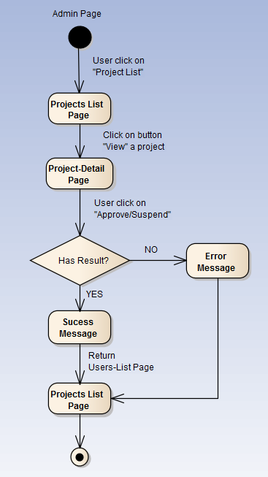

Figure 1‑1: Approve/Suspend workflow

Brief description: Admin can use this function. Steps:

* Step 1: User click on projects list.
* Step 2: System return projects list page.
* Step3: User click on button view
* Step 4: System return project detail page.
* Step5: User click on button Approved/Suspended
* Step 6: System return success message or error message.
* Step 7: System return projects list page.

#### Active/Inactive workflow

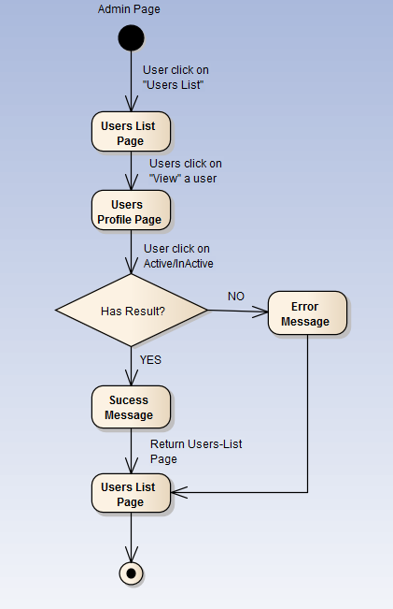

Figure 1‑2: Active/Inactive workflow

Brief description: Admin can use this function. Steps:

* Step 1: User click on users list.
* Step 2: System return users list page.
* Step 3: User click on button view a user
* Step 4: System return user profile page.
* Step 5: User click on button Active/Inactive
* Step 6: System return success message or error message.
* Step 7: System return users list page.

#### Add category workflow

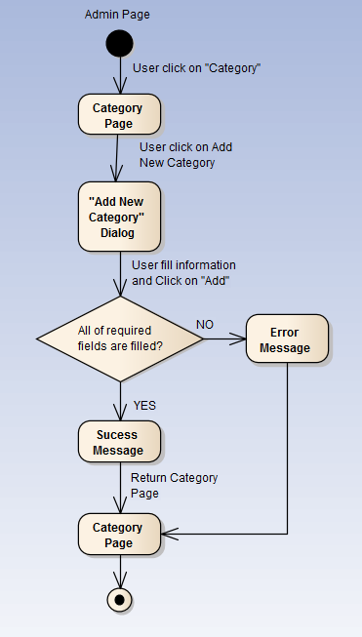

Figure 1‑3: Add category workflow

Brief description: Admin can use this function. Steps:

* Step 1: User click on Category.
* Step 2: System return category page.
* Step 3: User click on button new category
* Step 4: System return dialog “Add New Category”.
* Step 5: User fill information and click “Add”
* Step 6: System return success message or error message.
* Step 7: System return category page.

#### Add slider workflow

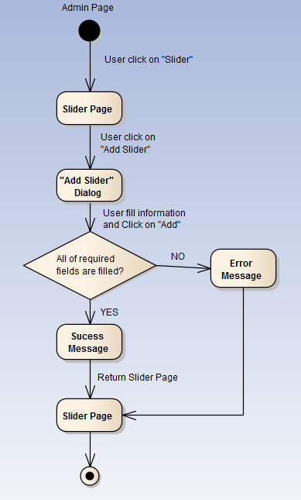

Figure 1‑4: Add slider workflow

Brief description: Admin can use this function. Steps:

* Step 1: User click on Slider.
* Step 2: System return slider page.
* Step 3: User click on button new slider.
* Step 4: System return dialog “Add New Slider”.
* Step 5: User fill information and click “Add”
* Step 6: System return success message or error message.
* Step 7: System return slider page.

#### Sent message workflow

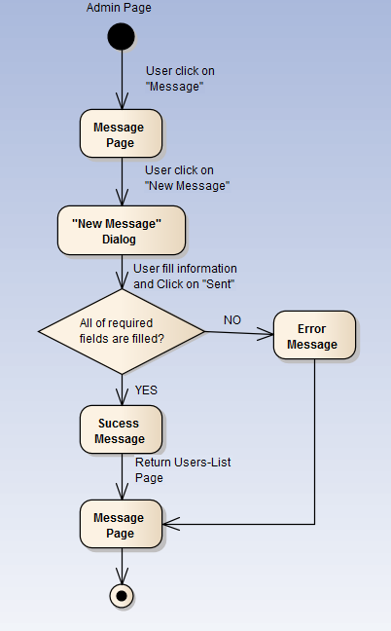

Figure 1‑5: Sent message workflow

Brief description: Admin or user can use this function. Steps:

* Step 1: User click on Message.
* Step 2: System return message page.
* Step 3: User click on “new message” button.
* Step 4: System return dialog “New Message”.
* Step 5: User fill information and click “Sent”
* Step 6: System return success message or error message.
* Step 7: System return message page.

#### Register workflow

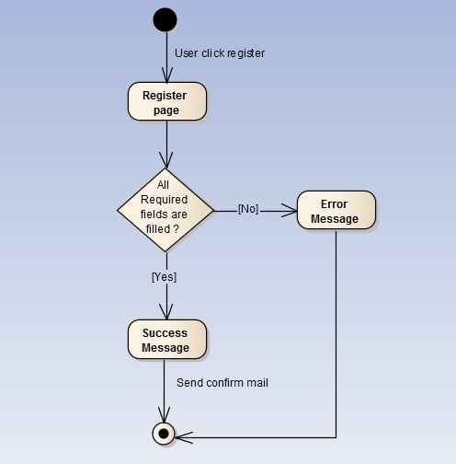

Figure 1‑6: Register workflow

Brief description: Guest can use this function. Steps:

* Step 1: User click register.
* Step 2: System return register page.
* Step 3: User fill all required fields and click Register or press Enter.
* Step 4: System return complete message.
* Step 5: System send confirm mail to user’s entered email.

#### Search workflow

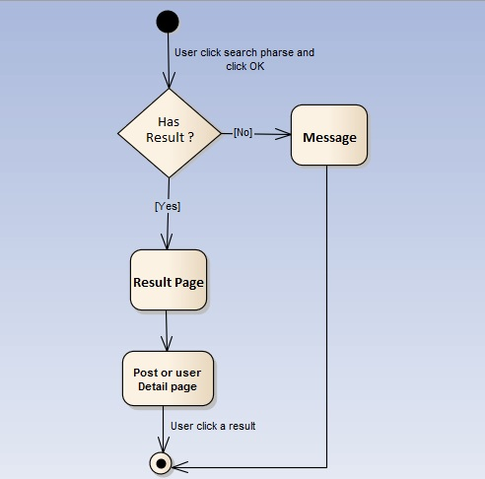

Figure 1‑7: Search workflow

Brief description: Guest and Member can use this function. Steps:

* Step 1: User input keyword into search text box and click Search or press Enter
* Step 2: System return search results or message if nothing found.
* Step 3: User can click returned results to view.

#### Comment workflow

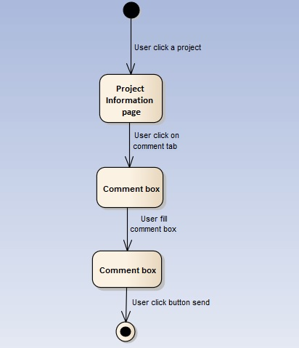

Figure 1‑8: Comment workflow

Brief description: Member can use this function. Steps:

* Step 1: User click on a project.
* Step 2: System return Project information page.
* Step 3: User click on comment tab.
* Step 4: System show comment tab.
* Step 5: User fill comment box.
* Step 6: User click sent.

#### Back a project workflow

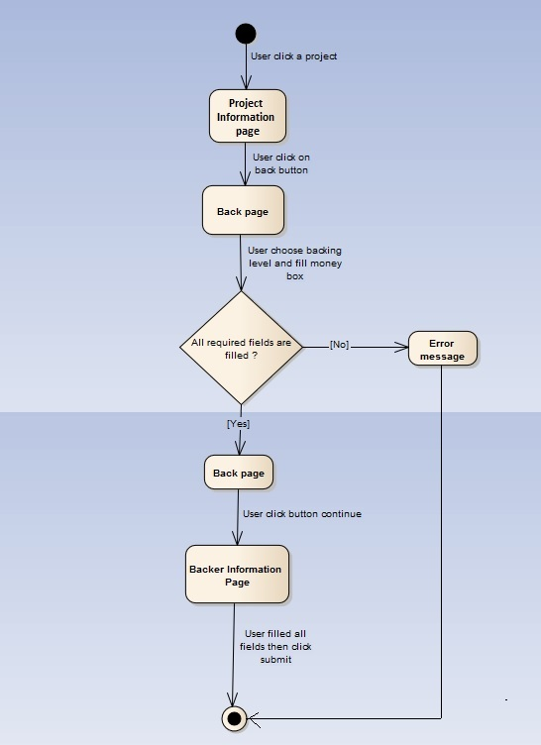

Figure 1‑9: Back a project workflow

Brief description: Guest and Member can use this function. Steps:

* Step 1: User click on a project.
* Step 2: System return Project information page.
* Step 3: User click on button back.
* Step 4: System return Back page.
* Step 5: User choose back level then click continue.
* Step 6: System return Backer information page.
* Step 7: User fill all fields then click submit.

#### Create a project workflow

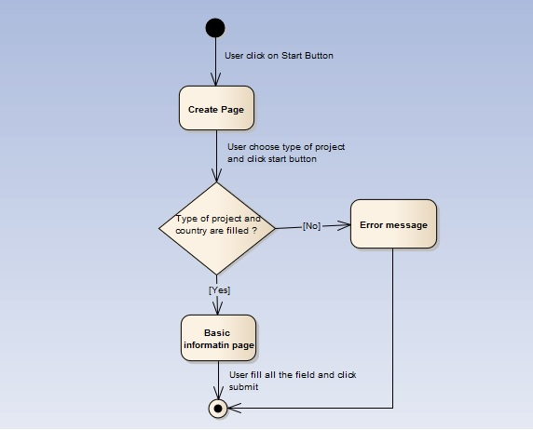

Figure 1‑10: Create a project workflow

Brief description: Member can use this function. Steps:

* Step 1: User click on start button.
* Step 2: System return Create page.
* Step 3: User choose type and country then click start.
* Step 4: System return Basic page.
* Step 5: User fill all the fields then click submit.
* Step 6: System return Backer information page.

#### Remind a project workflow

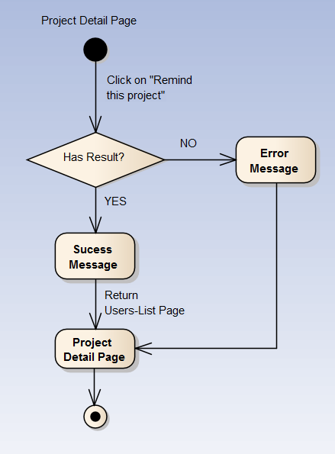

Figure 1‑11: Remind a project workflow

Brief description: Member can use this function. Steps:

* Step 1: User click on “Remind this project” button.
* Step 2: System return success message or error message.
* Step 3: System return Project Detail page.

#### Report a project workflow

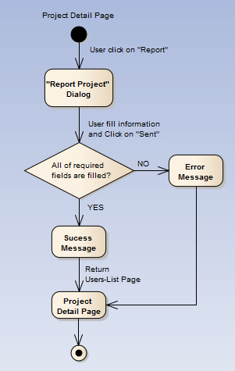

Figure 1‑12: Report a project workflow

Brief description: Member can use this function. Steps:

* Step 1: User click on report button.
* Step 2: System return “Report project” dialog.
* Step 3: User fill information and click “Sent”
* Step 4: System return success message or error message.
* Step 5: System return project detail page.

### Product Features

FAP is a website, user only connect to internet to use website. System provides these main functions:

#### Client features

* **Register:** User can register an account and login to use all features of DDL.
* **Login/Logout**: Users login/logout an account to use or exit system DDL.
* **Search:** User and guest can search with code of project, name of project, name of creator; and system will display all of project relate to keywords.
* **Filter:** User can filter with category (Art, Comics, Game, etc.), place (Earth, Vietnam, etc.), Status (Magic, Popularity, Most Funded, etc.). And system will display projects relate to these selected options.
* **Project**
  + Create New Project: Users can create new projects with basic info, reward, timeline, clip and some pictures.
  + Update Project Information: User can change and update information of projects which created.
  + Comment/Remind: Users can comment/remind a project to follow and discuss with another users.
  + Report: User can report a project which violate regulation to administrator.
* **Back Project**: User can back another project to donate money to help project success and get rewards.
* **Profile:**
  + Change password: User can change password to keep security.
  + Update profile: User can change or update information.
  + Manage created projects, backed projects, reminded projects: User can follow process of projects, follow project backed, project reminded. View statistical projects had created, backed, reminded.
  + Sent/Receive message: Users can send to or receive from other users to discuss about projects.

#### Admin features

* **Manage user:**
  + search user: Admin can search with name of user and system will display simple information about that user(name, email, phone number)
  + Inactive/active user: admin can set user’s account to inactive or active.
* **Manage project:** 
  + Search project :
  + Search with project name: Admin can search with name of project and system will display simple information about that project.
  + Search with category: Admin can search with category of project and system will display all project with that category
  + Search with Creator name: Admin can search with Creator name of project and system will display all project of that user.
  + Edit project status: Admin can set status of a project: pending to approved, pending to suspend, approved to suspend, etc.
* **Manage Backing:** Admin can view users who backed a project. Also, Admin can view simple information about that user and which reward they chose.
* **Manage Categories:** 
  + Add new category: Admin can add new category.
  + inactive/active category: Admin can set category’s status to inactive or active
* **Manage Slider:** Slider list includes images what running at homepage.
  + Add new image: Admin can add new image to slider
  + Inactive/active: Admin can set image’s status to inactive or active on slider.
  + Delete image: Admin can delete image.
* **Message:** Admin can view received messages/sent messages.
  + Compose new message: Admin can compose new message to send to user.
  + Delete message: Admin can delete received messages/sent messages.

### User characteristic

This website is a major platform for crowdfunding. Anybody could launch a project on Dandelion as long as it follows our rules. We believe that creative projects making a better world, and we’re thrilled to help support new ones. Building a community of backers around an idea is an amazing way to make something new. The website requires users to have the ability to use a browser with an internet connection. If users want to use all function, they must be login.

There are 2 main actors that system support:

* **Member:** Have account on system, they can use all functions of website. For example: Searching, create project, back project, etc…
* **Administrator:** They can use all functions of normal member and have an Administrator control panel to manage all configuration of system.

## Functional Requirements

### Common Module

**Access right: Member**

Functions of this module can be used by Guest and Member.

Guest or Member can search for their needs, results may be projects, creator, bankers or members’ name.

### Discover Module

**Access right: Member**

System suggest places, foods, drinks to members depend on their information, wish, places they have traveled. System also auto-detect member’s location or let member enter their location to suggest places that around member have traveled. If member sign in with Facebook, system can suggest their friends who are using services.

### Create Project Module

**Access right: Member**

Member can create their own posts to share their experiences, suggestion, comments, upload their videos, pictures. Member also can delete or modify what they have posted. Moreover, member can like, dislike, comment, share other members’ posts and contents, tag friends. Member can add or remove other members from Friends List and Follow List. Member can report posts or comments because of spam or rule violation.

### Back Project Module

**Access right: Member**

Member can create their own rooms to invite friends, other members to chat, discussion, make plans, starts up a trip. Member who created the room called as Room Admin, have all permissions of this room such as: invite, remove members, create, delete, modify room’s information, ban or unban from accessing, close and re-open room. When room’s members decide to do the trip, they can flag this room as done, and this room would be auto-closed.

### Message Module

**Access right: Member**

### Account Module

**Access right: Member**

Guest can uses Register function to sign up new account, Member can login to use member’s functions. Member can modify their information such as: name, age, phone number and choose which information would be public.

### Management Member’s account

**Access right: Administrator**

* Lock/Unlock Member’s Account: With this function, when a member violate some rules of website, Admin can block these member’s account temporarily, then these account cannot continue to use functions of website. Locked account will be unlocked when lock is expired. If these account violate rules one more time, Admin can lock account permanently.

Warn: If member violate the rules (reported by others), admin can send message to warn this people from stopping violation and delete/modify violated post.

### Management Project

**Access right: Administrator**

### Management Report

**Access right: Administrator**

* Delete Post: With this function, when a member post something on the wall but is reported by violate some rules of website, Admin can delete this post. Depending on severity, admin can lock or warn this user.

## Non-functional Requirement

* Easy to maintain and upgrade
* Ensure data security capabilities, high performance
* GUI is clear, friendly and easy to use.
* System has clear permission for user and can support multi roles.
* Scalability system